PYTHON DEVELOPER INTERNSHIP
(TASK 1)
File Handling, Automation, Exception Handling
Complete Code:
# File Handling, Automation and Exception Handling
import os
import shutil

try:
# Step 1: Create and write a text file
file = open("student.txt", "w")
file.write("Name: Hamelee\n")
file.write("Course: Python Internship")
file.close()
print("File created successfully")

# Step 2: Read the file
file = open("student.txt", "r")
content = file.read()
print("\nFile Content:")
print(content)
file.close()

# Step 3: Rename the file
if os.path.exists("details.txt"):
os.remove("details.txt")
os.rename("student.txt", "details.txt")
print("File renamed successfully")

# Step 4: Create Backup folder
os.makedirs("Backup", exist_ok=True)

# Step 5: Move file to Backup folder
destination = "Backup/details.txt"
if os.path.exists(destination):
os.remove(destination)
shutil.move("details.txt", destination)
print("File moved successfully")

# Step 6: Delete the file
os.remove(destination)
print("File deleted successfully")

except FileNotFoundError:
print("Error: File not found")
except PermissionError:
print("Error: Permission denied")
except Exception as e:
print("Error:", e)
Code Screenshot:
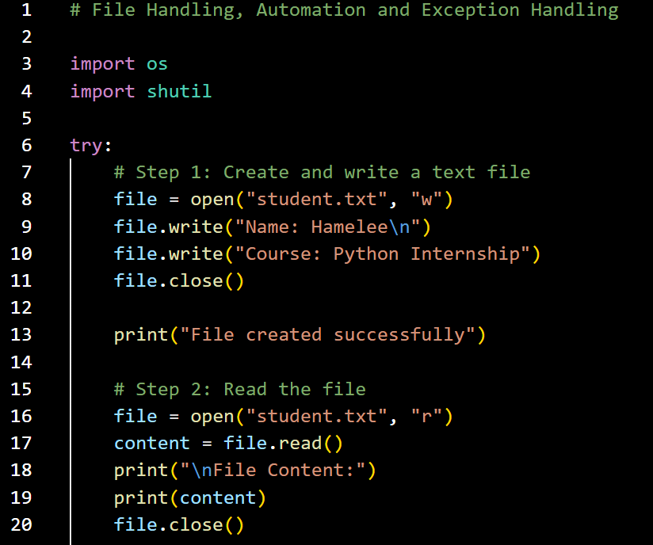
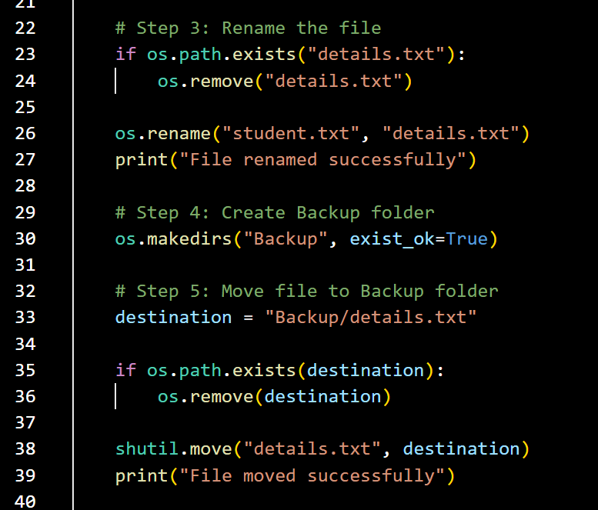
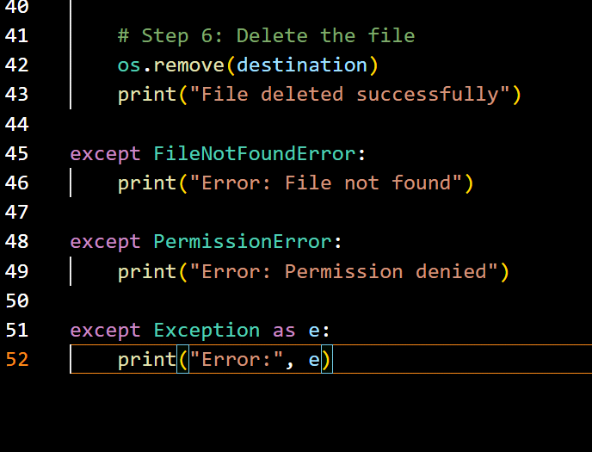
Create and write a File:
# code snippet:
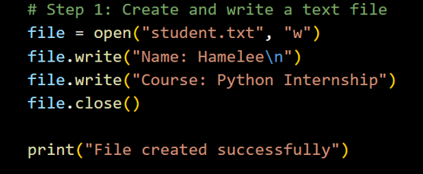
# output:
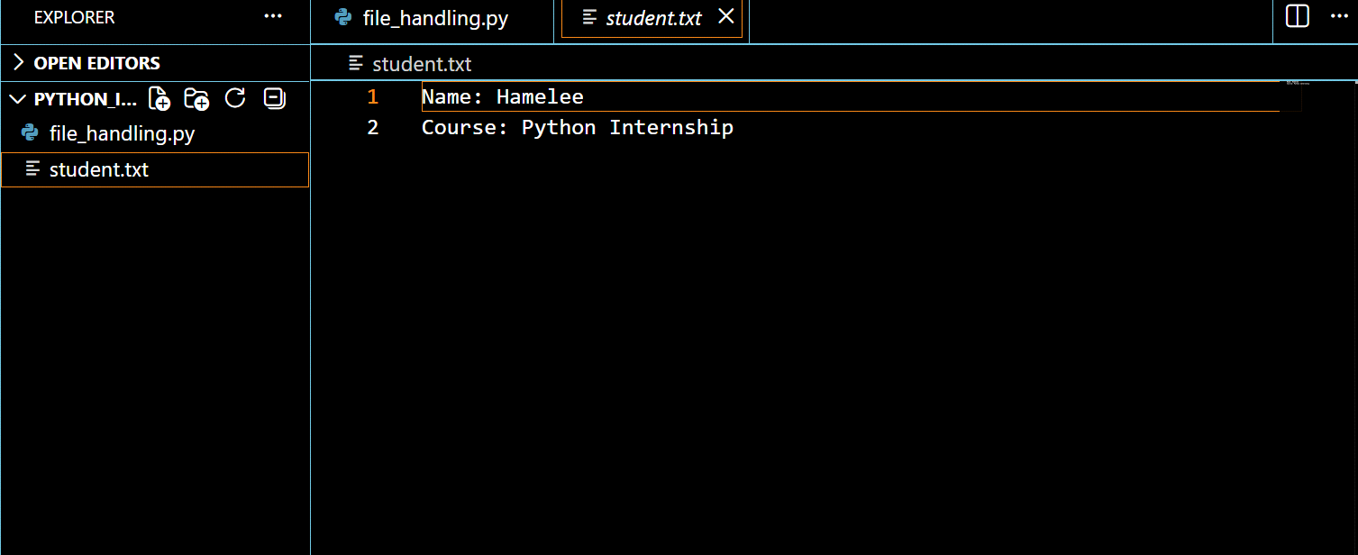
Read the file:
# Code Snippet:
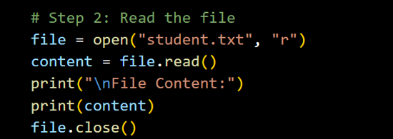
# output:
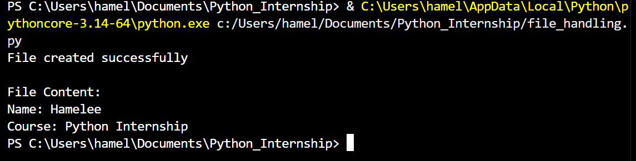
Rename the file:
# Code snippet:
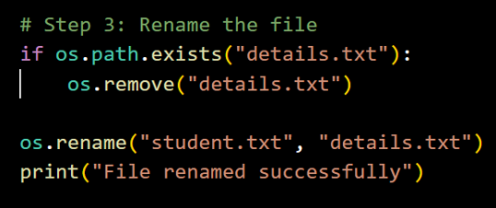
Create Backup Folder:
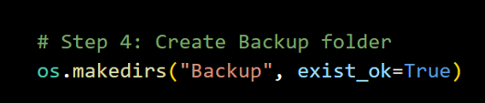
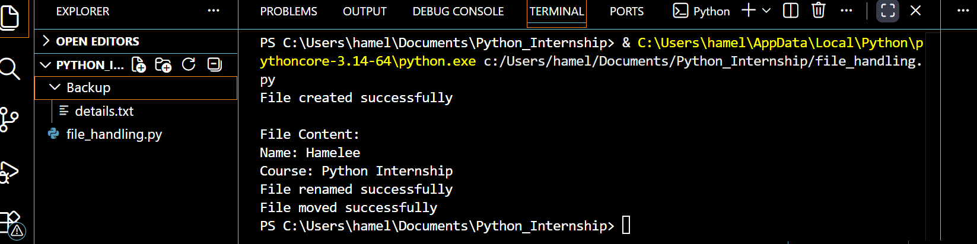
Move file to backup folder:
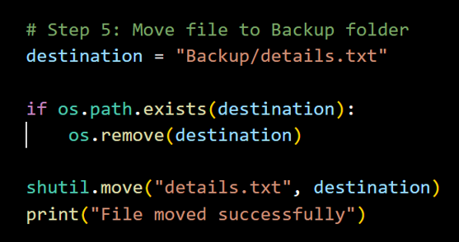

Delete the file:

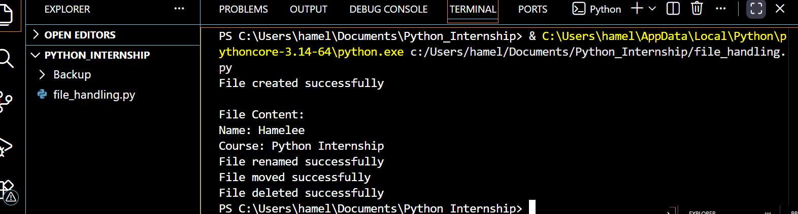
Final Output:
